**National Ski Patrol Certification System**

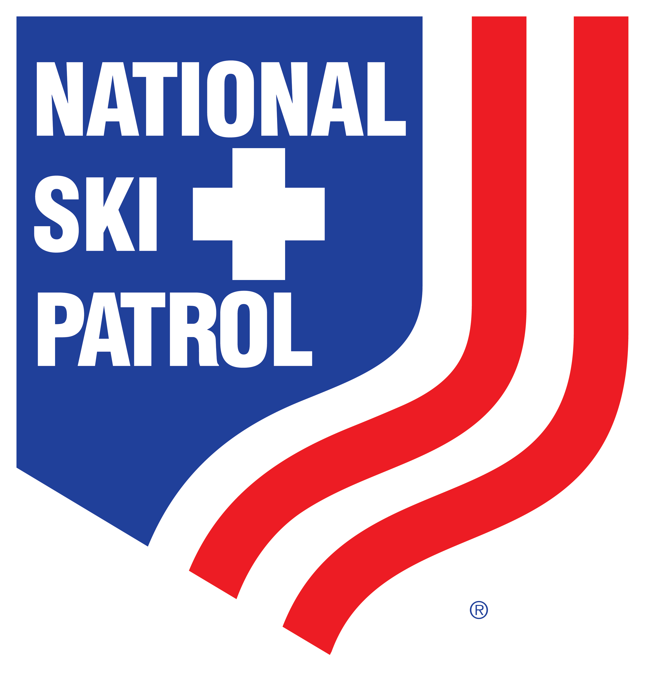 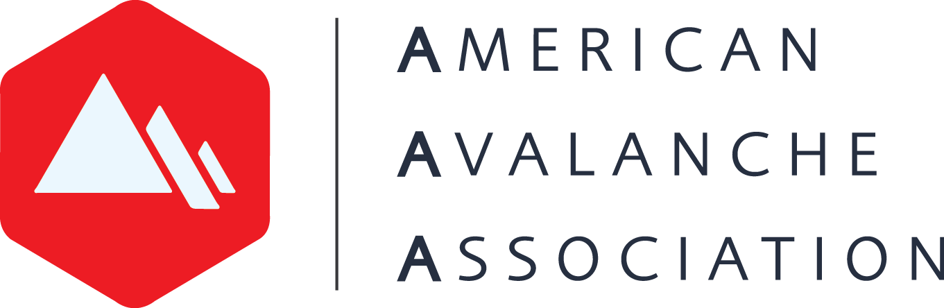

**American Avalanche Association Membership Levels**

**Purpose:** The purpose of the A3 credentialing system is to maintain adequate tracking for American Avalanche Association membership. Since instructors are required to maintain membership if teaching avalanche level 1 courses, badges help keep track of who has appropriate A3 membership levels to be instructors and IORs.

**Certification Instructions**: In the NSP Center for Learning (National Ski Patrol’s LMS), avalanche instructors wishing to teach Companion Rescue and the different modules of Level 1 Avalanche courses will go to the course catalog, click on the Avalanche Category, and enroll themselves in the following courses:

1. **For Instructor of Records (Lead Instructors)**: American Avalanche Association Pro Membership
2. **For Instructors:** American Avalanche Association Affiliate Membership

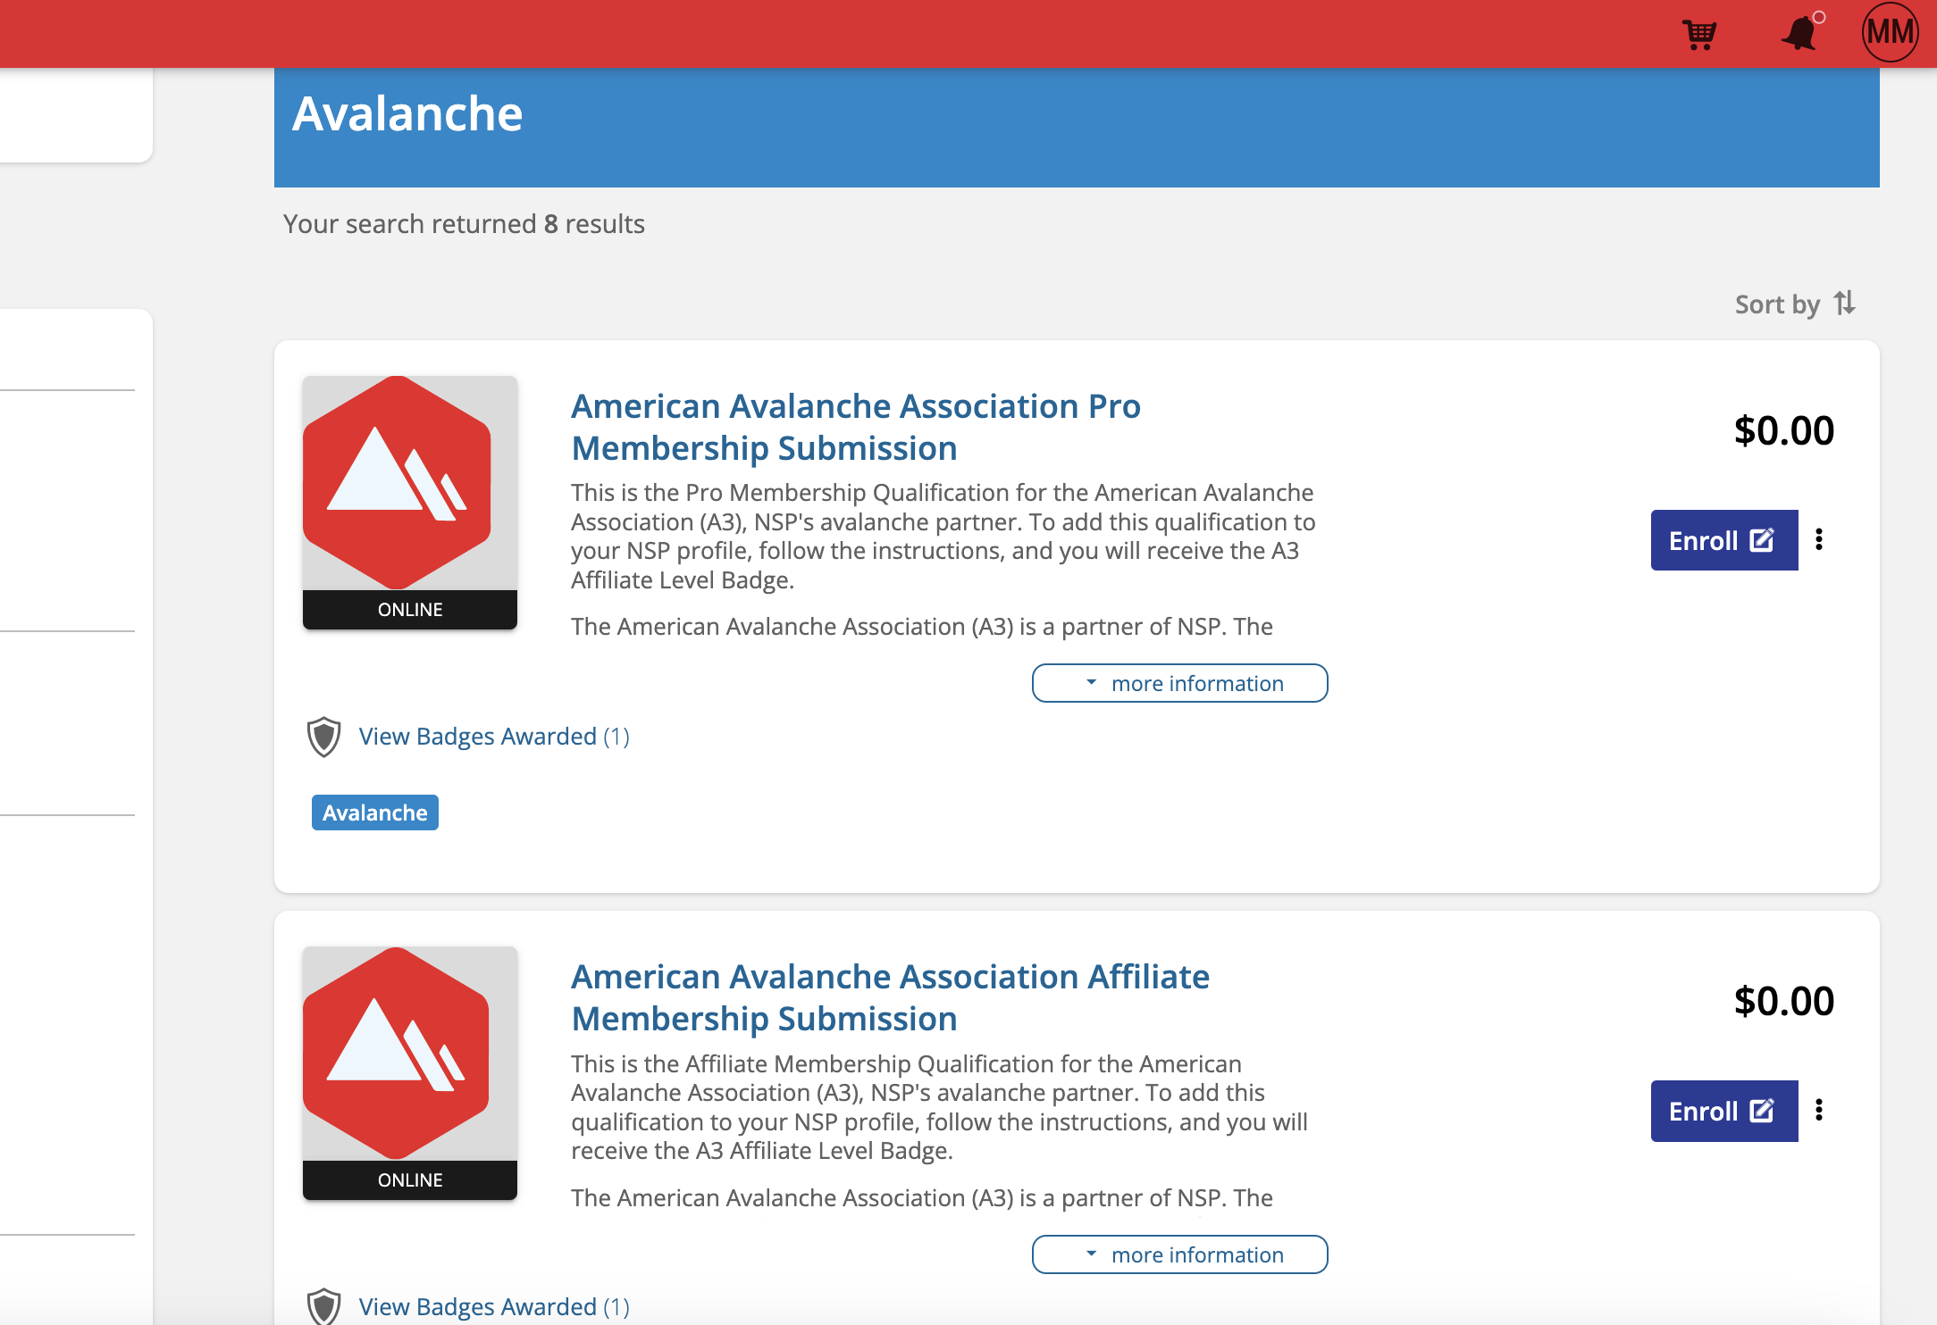

In these courses, there are instructions and a submission portal where the instructors are prompted to upload one of the following options for proof of A3 membership:

* A screenshot of their A3 member profile including their next membership renewal date and membership level.
* An email message from A3 verifying receipt of your current membership dues and membership level.

Once that proof of membership is submitted, NSP Staff and the National Avalanche Committee will approve the submissions. This system will enable NSP to provide a report to A3 on instructors’ membership status.

**Expiration**: These certifications expire each year on October 31, so instructors will need to maintain and verify their A3 membership status each year.