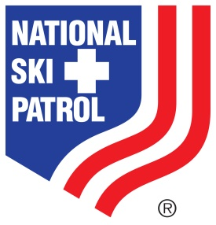 **2024 AFFILIATE DUES PAYMENT INVOICE**

Date:

To:

For:

Amount: 2024 Affiliate Fee - $400.00

Total Amount Due - $400.00

* To pay by credit card please call the NSP office, (303) 988-1111 ext 2661, and have a valid credit card and your Affiliate ID number readily available**.**
* If you prefer to pay by check, please make check payable to **National Ski Patrol, and include your Affiliate Member ID on the check**.
* Please review this Notice for accuracy.

Mail to: National Ski Patrol

133 S Van Gordon St. suite 100

Lakewood, CO 80228

Check#:

Questions: Please contact Karen Moldenhauer; [memberrecords@nsp.org](mailto:memberrecords@nsp.org)

303.988.1111 ext. 2661