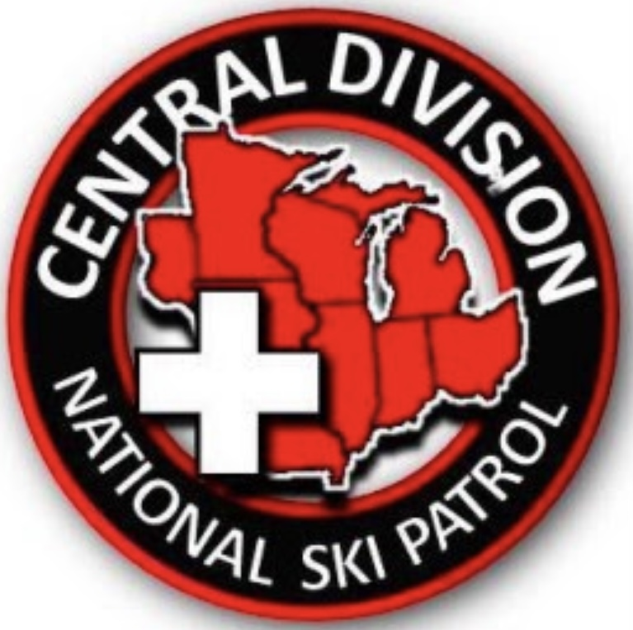

Central Division Planning Guide
Fall Division Meeting

Introduction
Your Region has the pleasure of hosting the Fall Division meeting. This booklet was made to help answer general questions regarding meeting planning to help guide you. Included are basic needs and ideas from previous meetings by other regions that have worked well for this event.

The rotation for hosting is from the Division Policies and Procedures found on our website. Another resource of information is the Division Meeting Supervisor.

Index
- Timeline for Planning
- Meeting Needs
- Planning Resources
- Guests and Dignitaries
- Fundraising for the Event
- Educational Offerings
- Activities

- Timeline
18-24 months Form a search committee
to find a location to hold
the meeting. (See meeting needs for qualifications). Confirm and sign contractual agreement for location. Set up a meeting committee to prepare for the event. Please
consider the overall cost and the approved reimbursement for both lodging and meals found in the Division P & P in your search.
12 months Have a brief presentation prepared
to introduce the plans at the Fall Division Awards Meeting for the following year.
9 months Advertise the meeting utilizing social media, RPN, and email blasts (save the date type notice). Investigate payment process options and run trials before it is blasted to the Division for operational accuracy.
6 months Place sign up information on the division website with links to hotel reservations and all pertinent sign-up links.
Send out email blast to division with invitation to event. Utilize social media to encourage participation in the event.

3 months Reevaluate all plans. Make any necessary adjustments as sign-up numbers come in. Continue to advertise the meeting. Increase the frequency on social media.

1 month Confirm all plans as obligated with vendors and Region staff.

- Meeting Needs
- Friday
- Check-in table for duration of the event
- Dinner gathering -consider menu options to meet needs including allergies.
- Educational or social offerings
- Saturday
- Check-in table for event duration
b. General Session 9 am- noon at latest (no competing activities)
c. Division Board Meeting from 12 pm- 5 pm
d. Educational offerings, Face to Face meeting as necessary
e. Social activities for family accompanying members highlighting local interest.
- Division Awards Dinner; 6 pm cocktails, 6:30 dinner, awards.
- Sunday
a. Patrol Director’s Breakfast
b. Educational or meeting offering if interest or need.

- Planning Resources
- ADD overseeing meetings, Division Meeting Advisor should be included in your planning committee.
- Previous committee for previous year data including attendance.
- Local tourists planning resources, hotel event planners.
- Division Director may have specific needs for the meeting.
- All ADDs as a Division Advisor may have a special need to convey.
- The Division Website Advisor is a great resource for your committee and should be included in your planning committee.

- Guests and Dignitaries
The Division may invite special speakers or national guests. They may require room reservations or other special accommodations that will be conveyed to your committee.
- Fundraising for the Event
- Fundraising efforts are made to help offset the cost of the meeting for the Region.
- Fundraising efforts must comply with the P & P of both Division and National.
- Previous meetings have included a silent auction and have become an expected event looked forward to by many attendees.

- Educational Offerings
- The following contains a list of some of the previous educational offerings: CPR, ID, Avalanche, Chair Evacuation, Aid Room Module, ORM, OEC Instructor recerts, OEC Enhancement Seminars, Bike Seminars.
- A Division Program may plan a Face-to-Face meeting. Generally these need Division Board expense approval. (ADDs will have this information).
- The Division Director may have a special request as they will have current information on new programs as well as program updates.

- Activities
- These have included local features and attractions for family members as well as patrollers to enjoy.
- The following is a list of some of the previous social activities: art fairs, orchards and cider mills, wine tasting, kayaking, motorcycle tour, museums, or any local attraction.

