Contribution Form

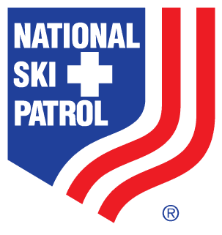 Charles "Minnie" Dole

Service and Safety Memorial Contribution

Decades of Safety and Service

Deceased Patroller Information (please print or type)
Name of Patroller
How deceased was instrumental in ski patrolling and/or the ski industry
Home Patrol or Family Member’s Patrol
Mountain Resort

Benefactor Information (please print or type)
Name of benefactor
Address of benefactor
City
State
ZIP Code
Phone number of benefactor
Name and address of family member to be contacted about donation
Phone number of family member

Pledge Information
I (we) pledge a total of $
I (we) plan to make this contribution in the form of:
cash check credit card
Credit card type
Credit card number
Expiration date
Authorized signature

Charles “Minnie” Dole Service and Safety Memorial Fund

Decades of Safety and Service

Acknowledgement Information
Please write how name should appear on plaque:
I (we) wish to have our gift remain anonymous.
Signature(s)
Date
Please make checks, corporate matches, or other gifts payable to:
National Ski Patrol Memorial Contribution
Attn: Finance and Awards Department
133 S. Van Gordon St. Ste. 100
Lakewood, CO 80228

